**Project Report Template**

**1.INTRODUCTION**

**1.1Overview**

**A brief description about your project**

A Sleep Tracking App for a Better Night's Rest

* A project that demonstrates the use of Android Jetpack Compose to build a UI for a sleep tracking app.
* The app allows users to track their sleep.With the “Sleep Tracker”

app, you can assess the quality of sleep they have had in a day.

* It has been time and again proven that a good quality sleep is pretty essential for effective functioning of both mind and body.

**1.2 Purpose**

**The use of this project. What can be achieved using this.**

* “Sleep Tracker” application enables you to start the timer when they are in the bed and about to fall asleep.
* The timer will keep running in the background until it is stopped, whenever the user wakes up.
* Based on the sleep experience, you can rate your sleep quality.
* Finally , the app will display an analysis of the kind of sleep , you had the previous night.

By end of this project:

● You’ll be able to work on Android studio and build an app.

● You’ll be able to integrate the database accordingly.

**2.Problem Definition & Design Thinking**

**2.1 Empathy Map**

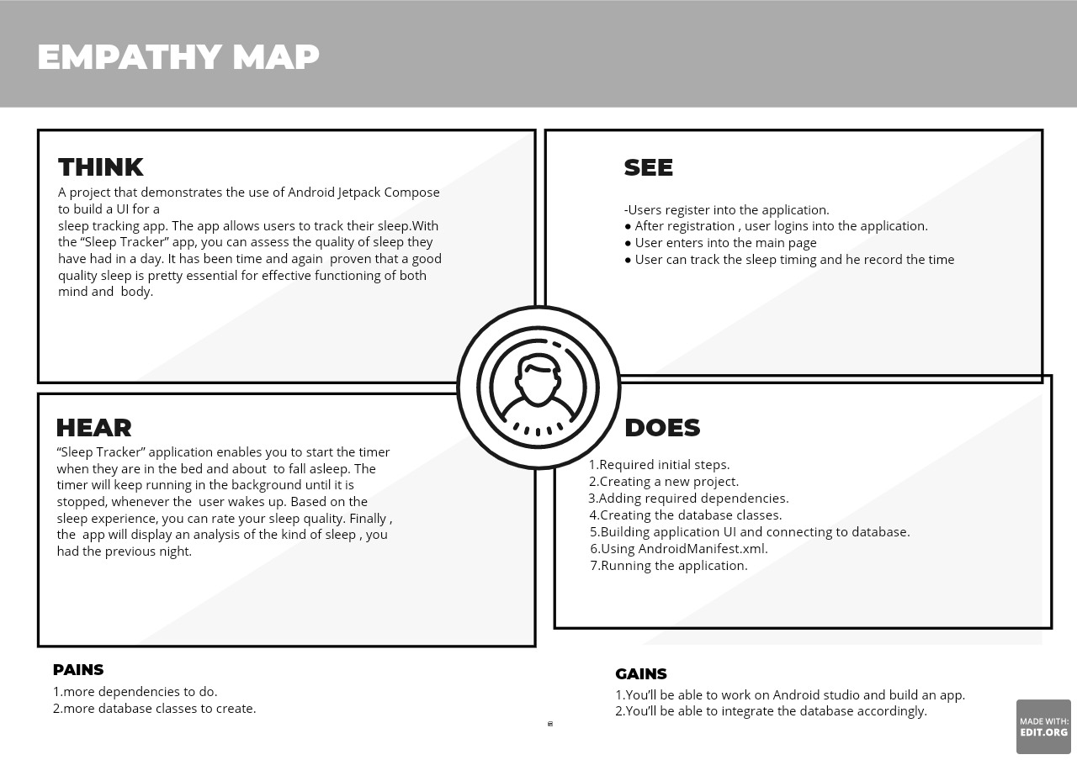

**2.2 Ideation & Brainstorming Map**

[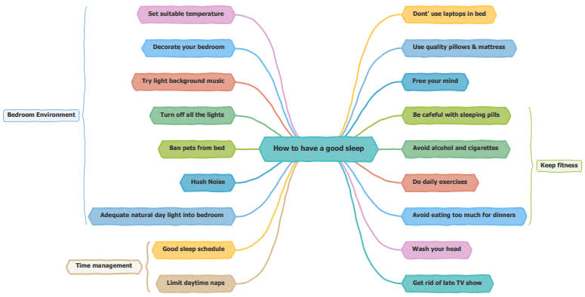](https://www.google.com/search?safe=active&q=ideation+map+and+brainstorming+map+for+sleeping+#imgrc=s989-PXVhbr_SM&lnspr=W10=)

**3.RESULT**

**3.1 Data Model:**

**Object name Field**

| **Object name** | **Fields in the object** |
| --- | --- |
| **Obj 1**  **1.data access object**  **2.user DAO interface** | | **Field table** | **Data type** | | --- | --- | | **Gradle scripts** | **Classes** | | **Activity** | **Code** | |
| **Obj 2**  **1.Entities**  **2.time log data class** | | **Field table** | **Data type** | | --- | --- | | **Dependencies** | **Database** | | **DAO interface** | **Class** | |

3.2 Activity & Screenshot

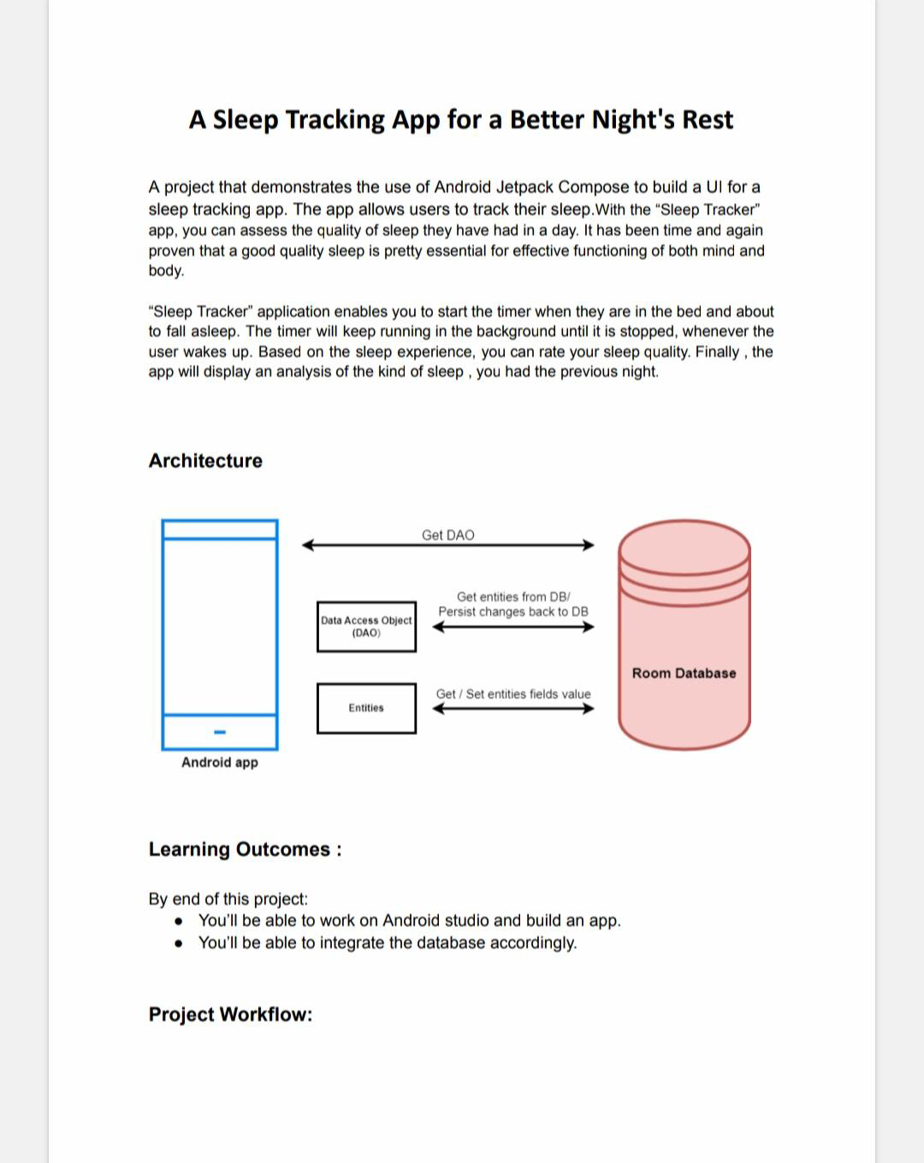

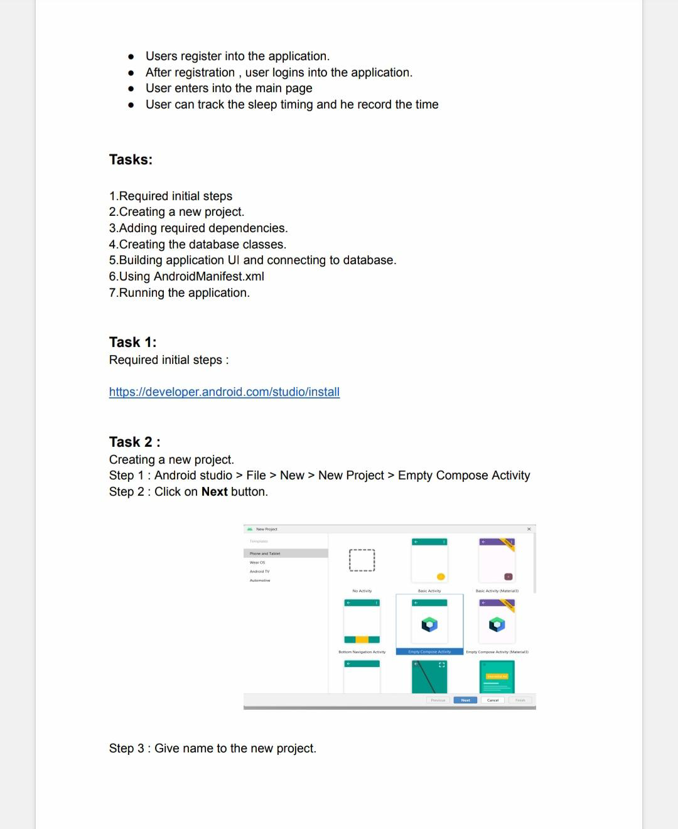

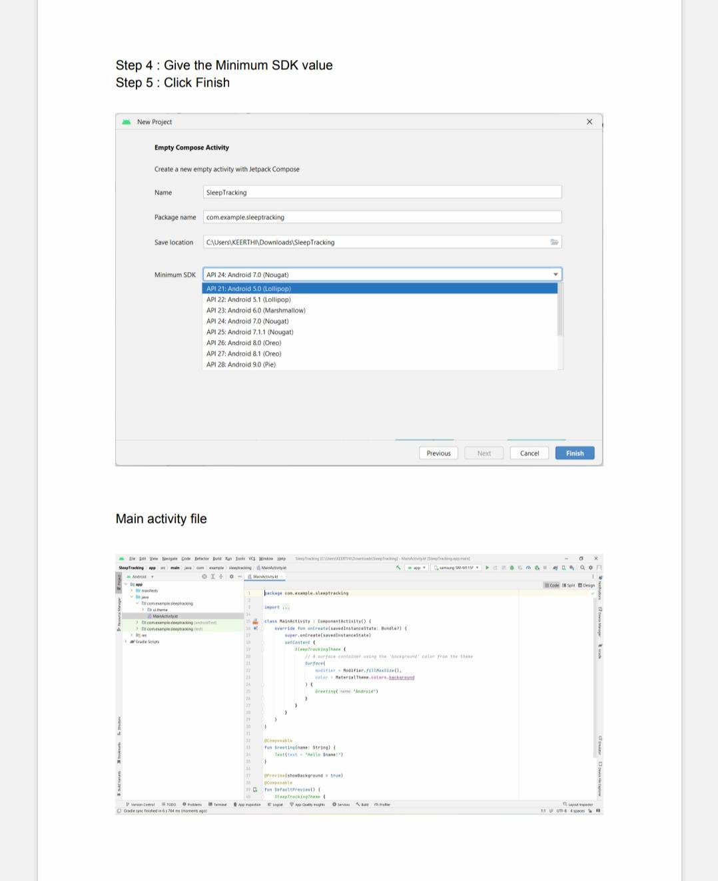

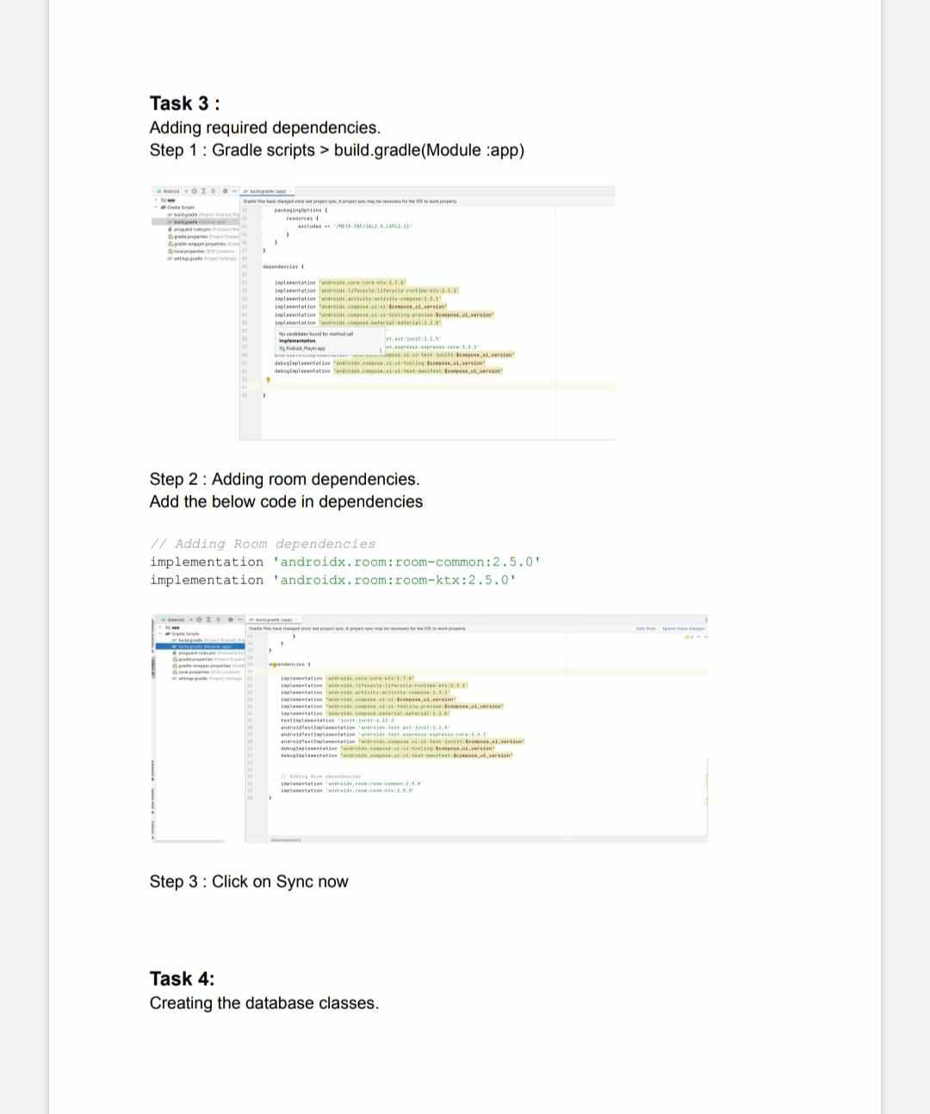

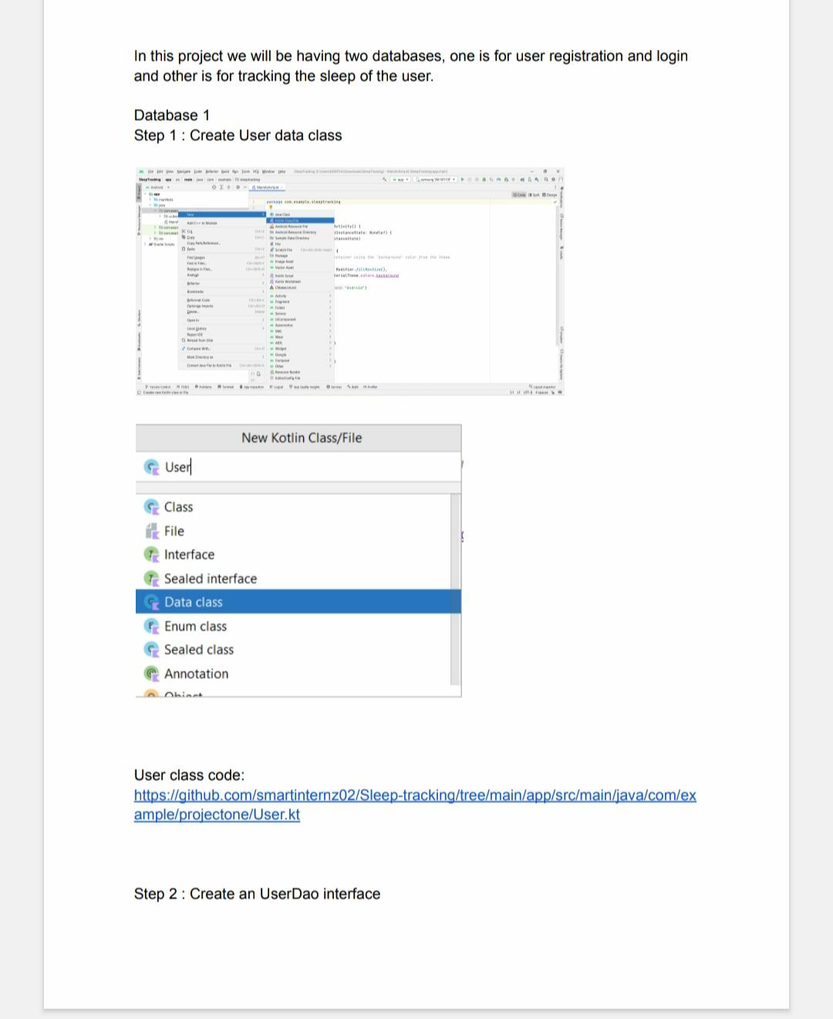

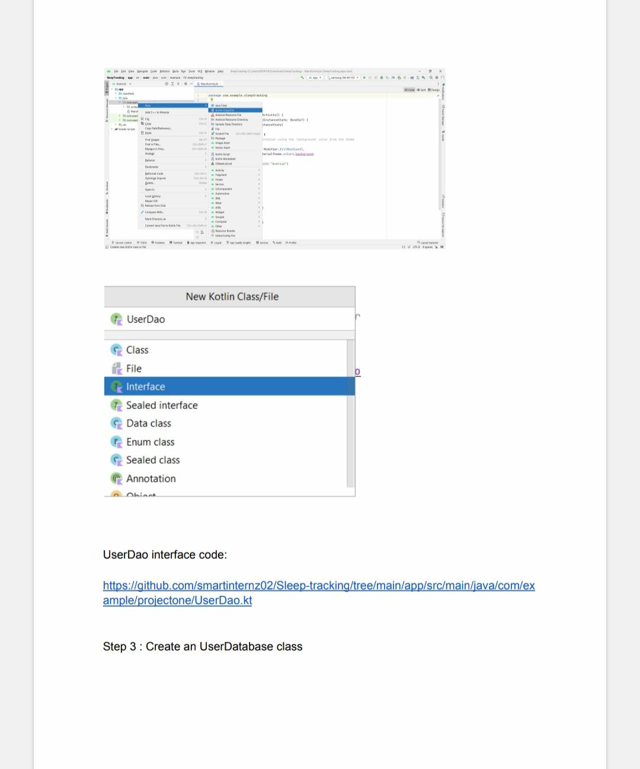

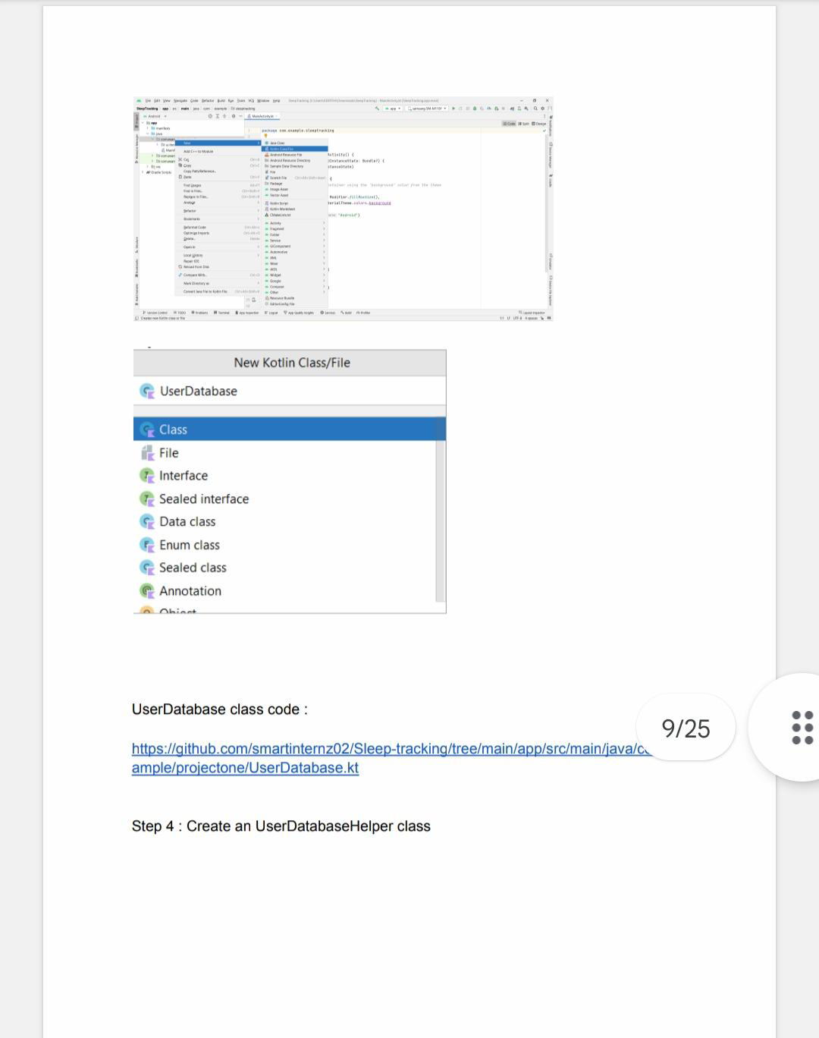

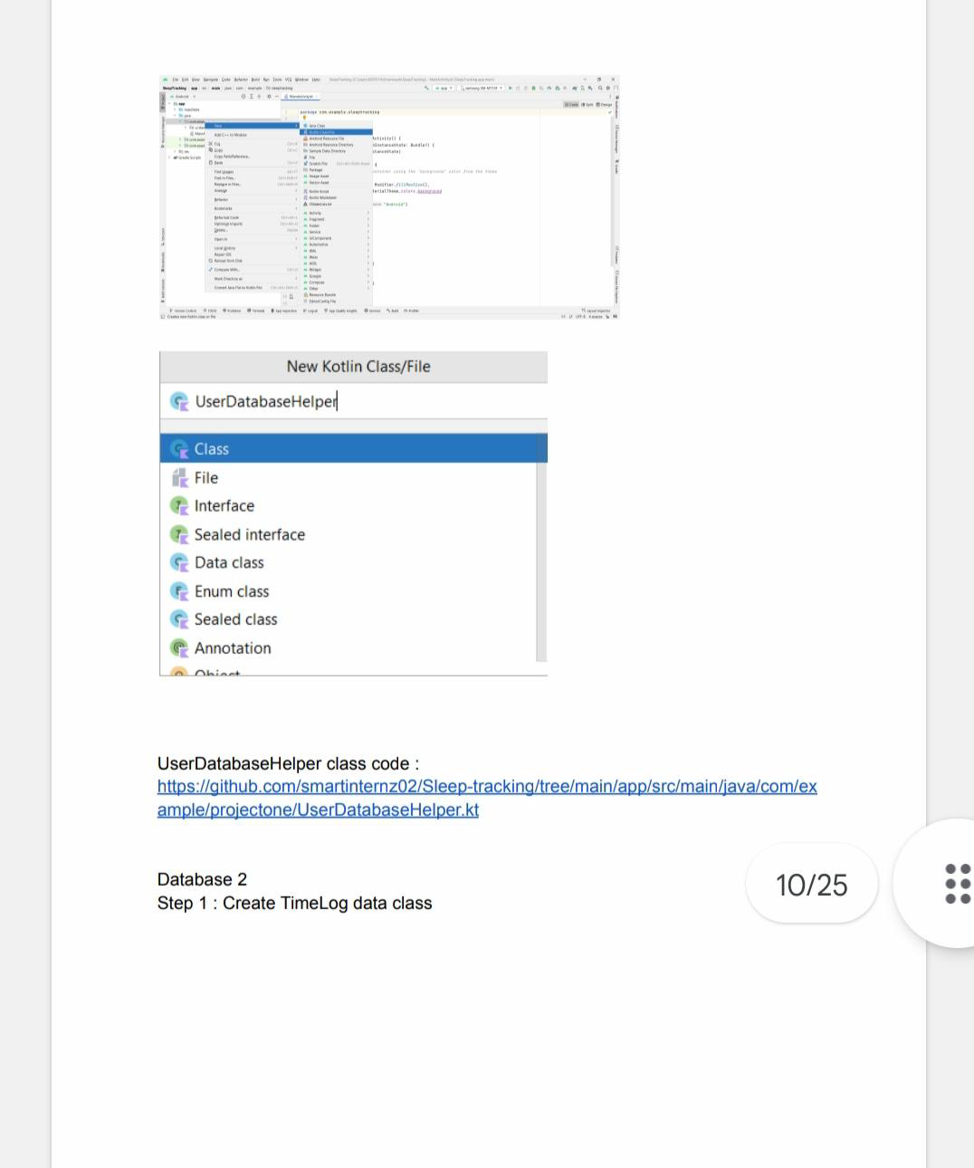

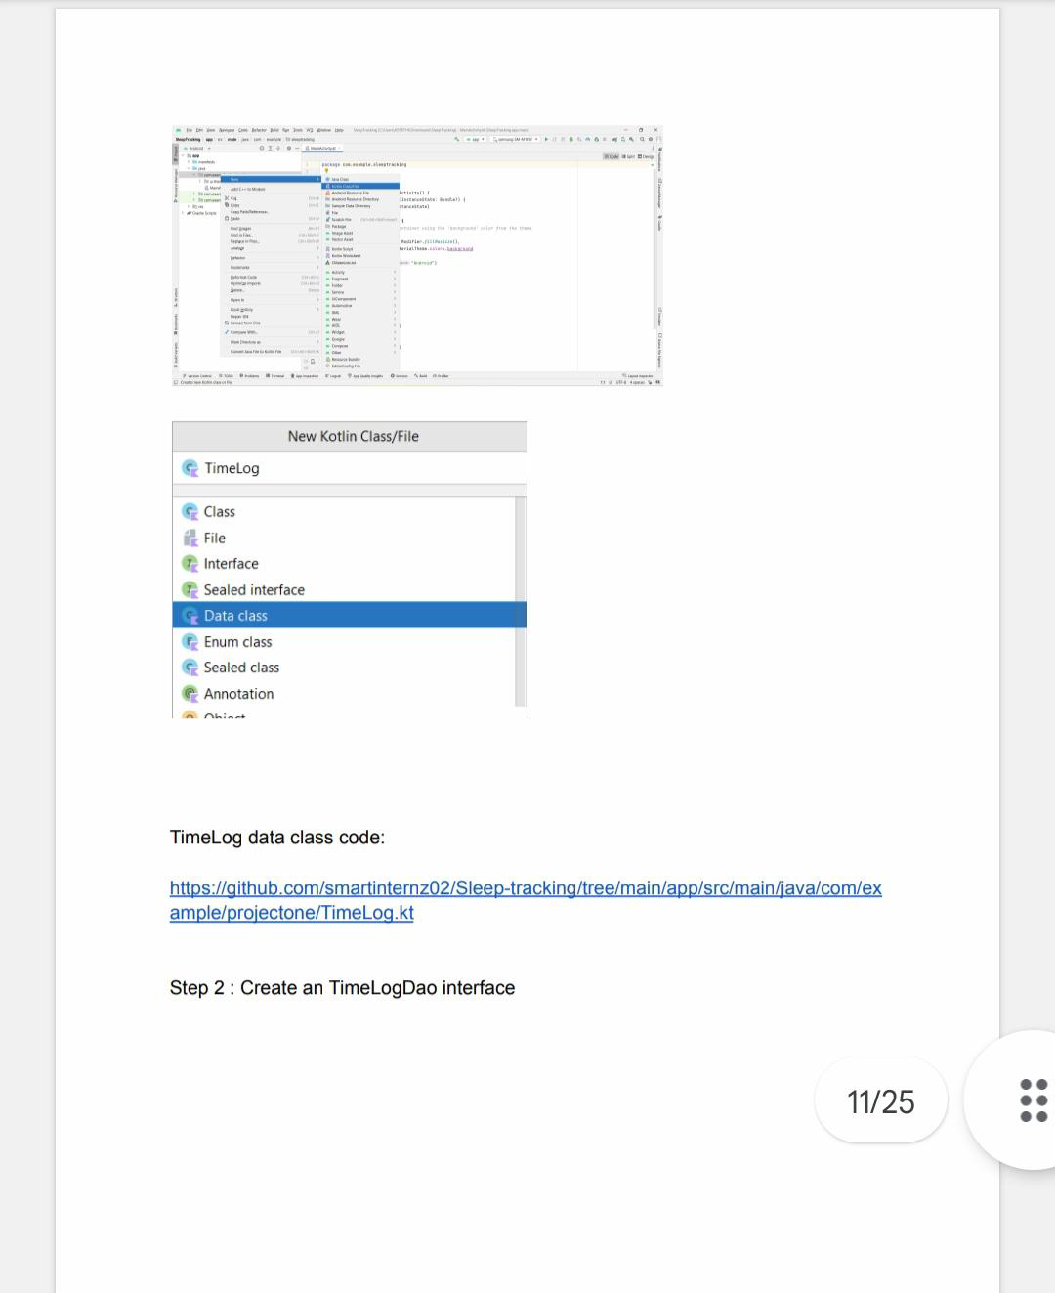

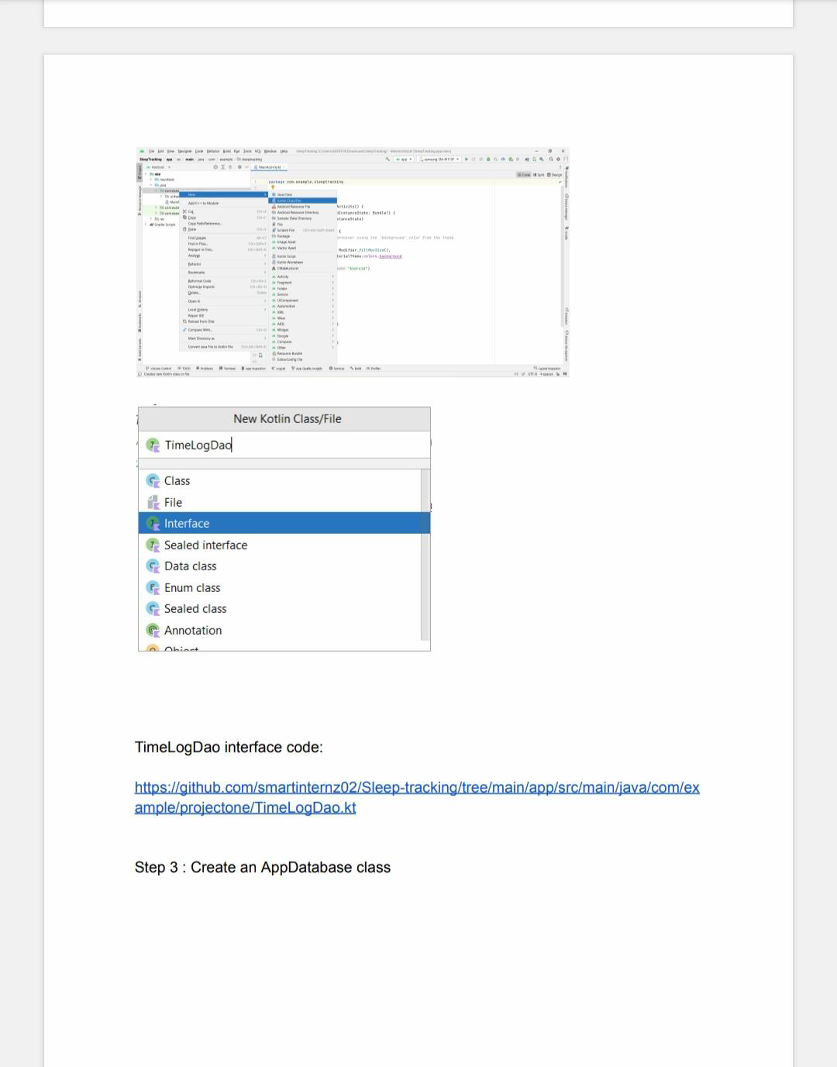

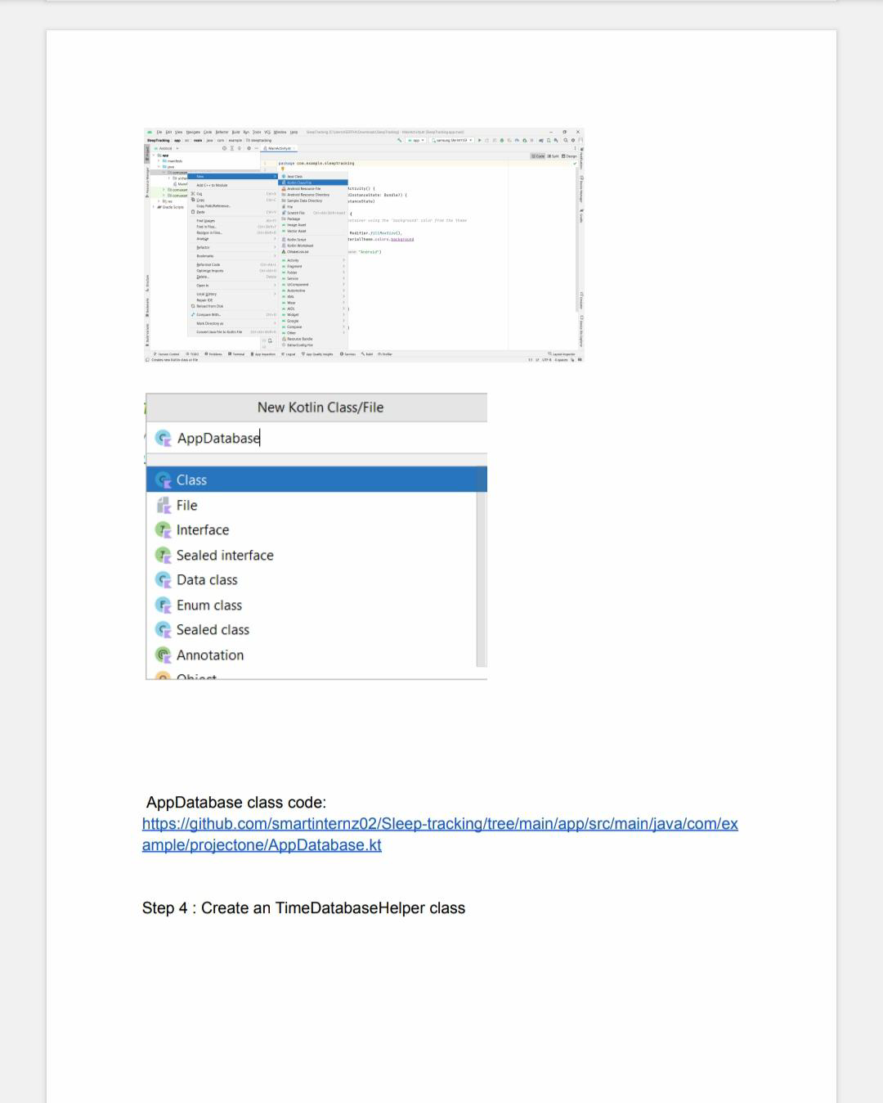

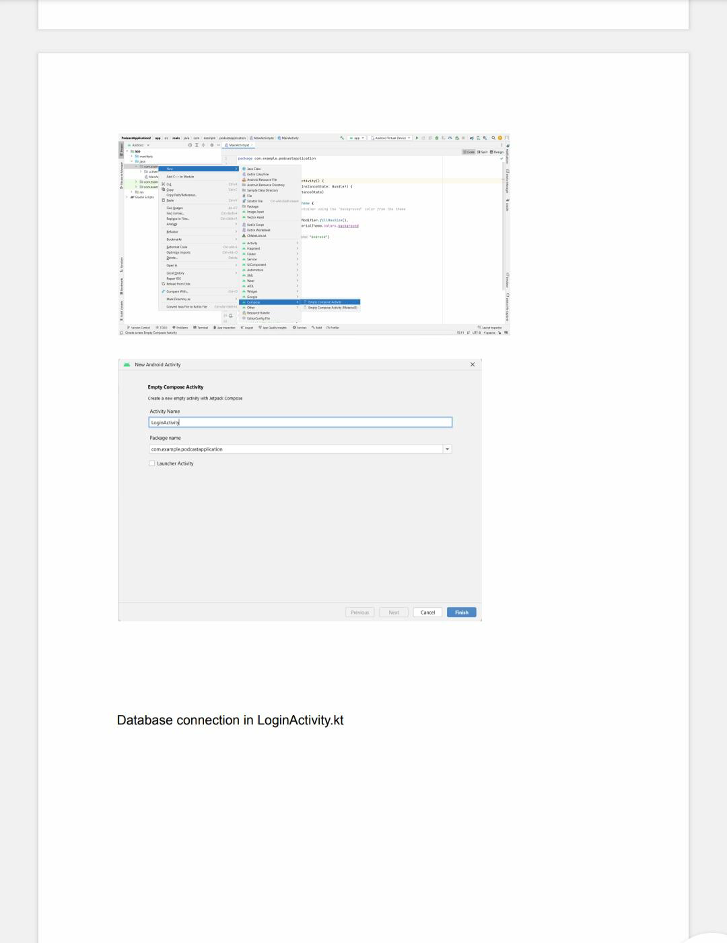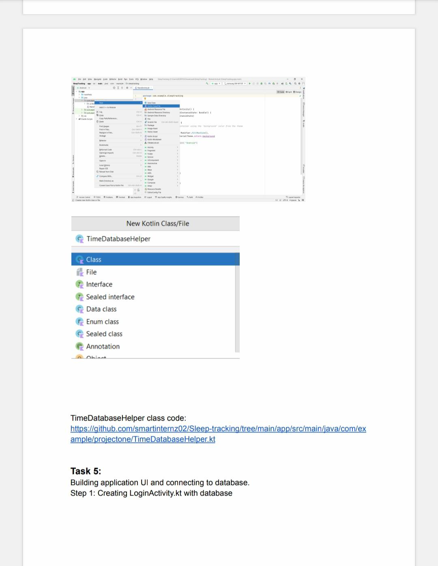

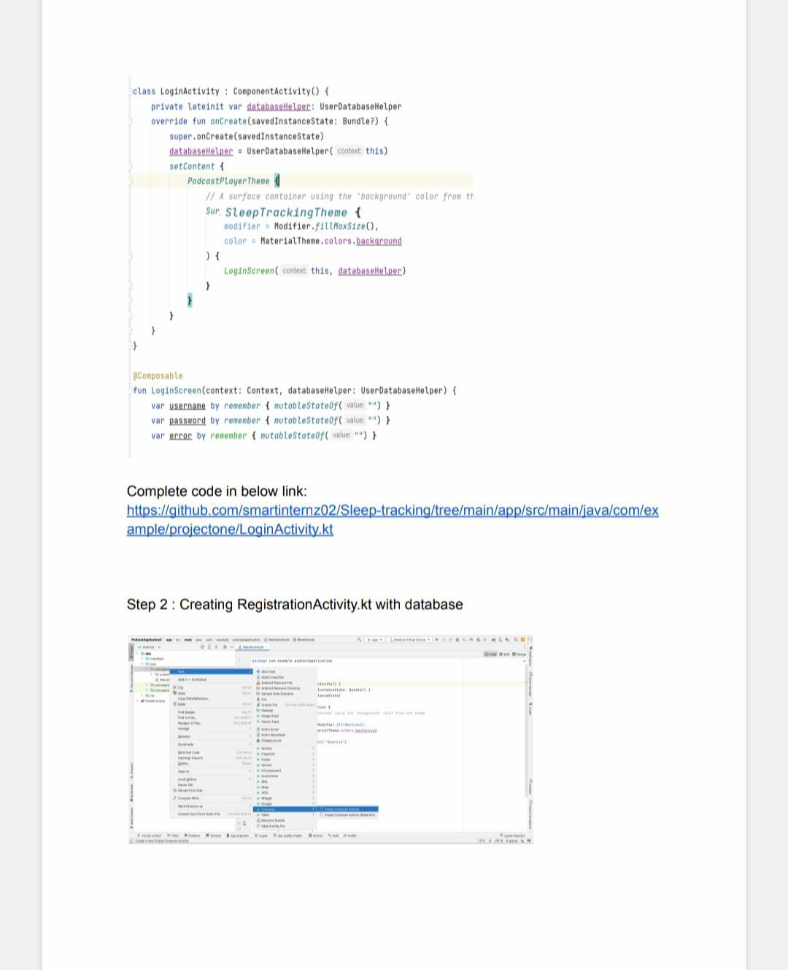

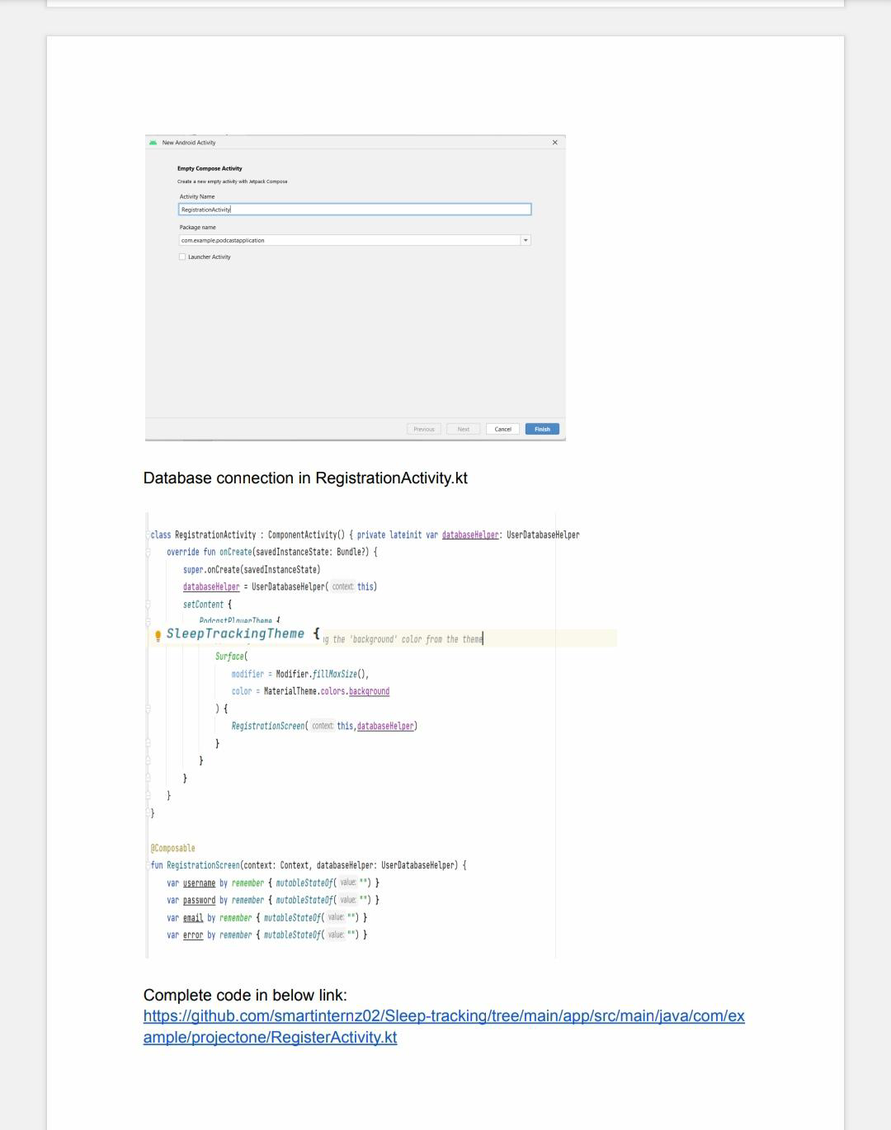

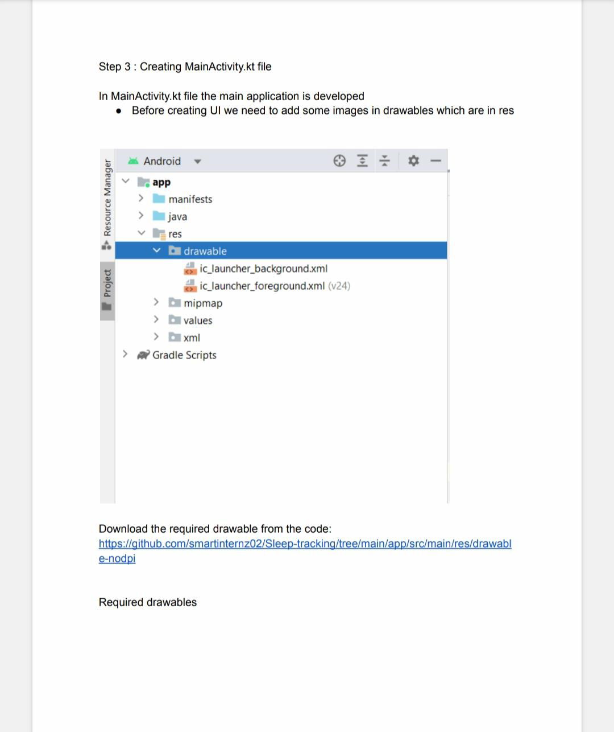

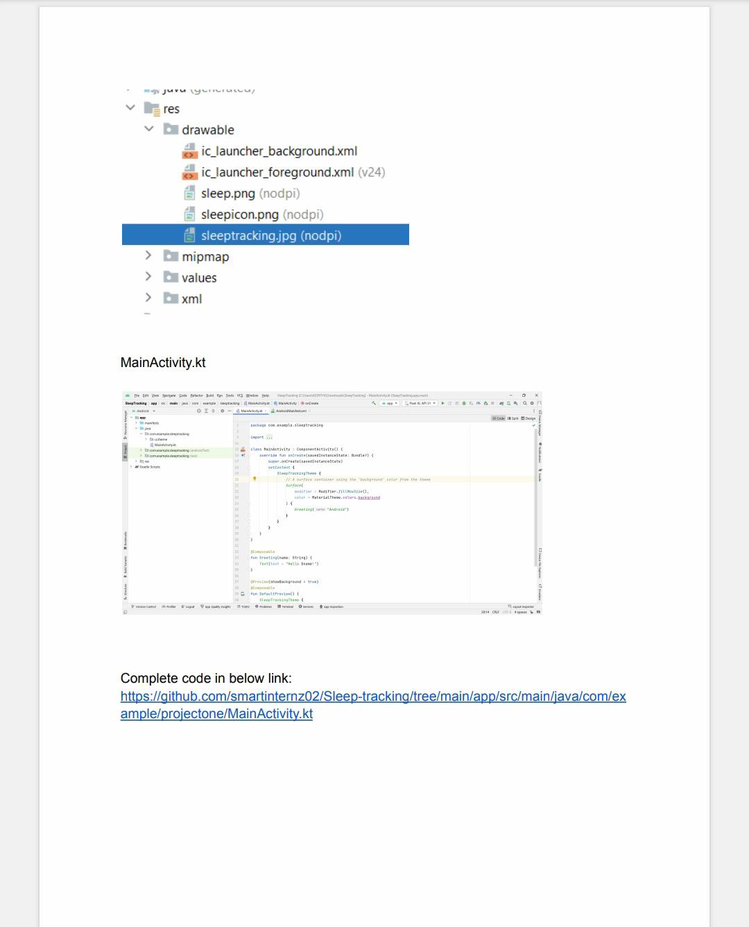

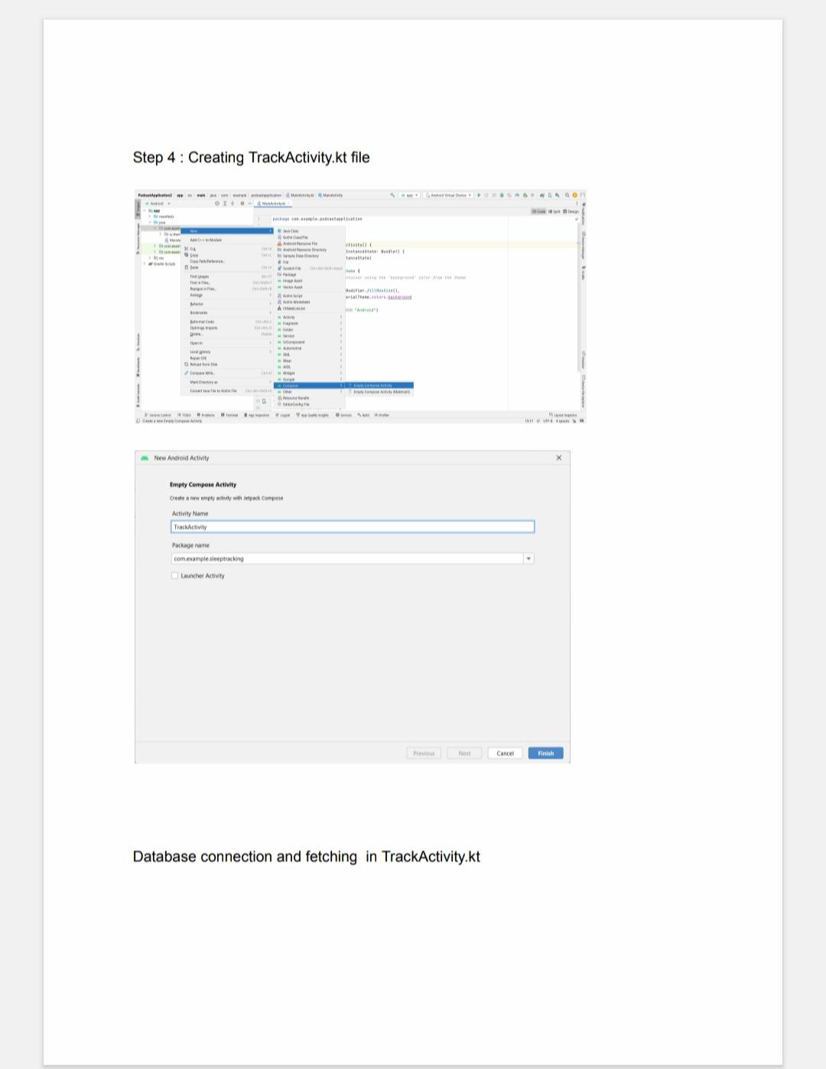

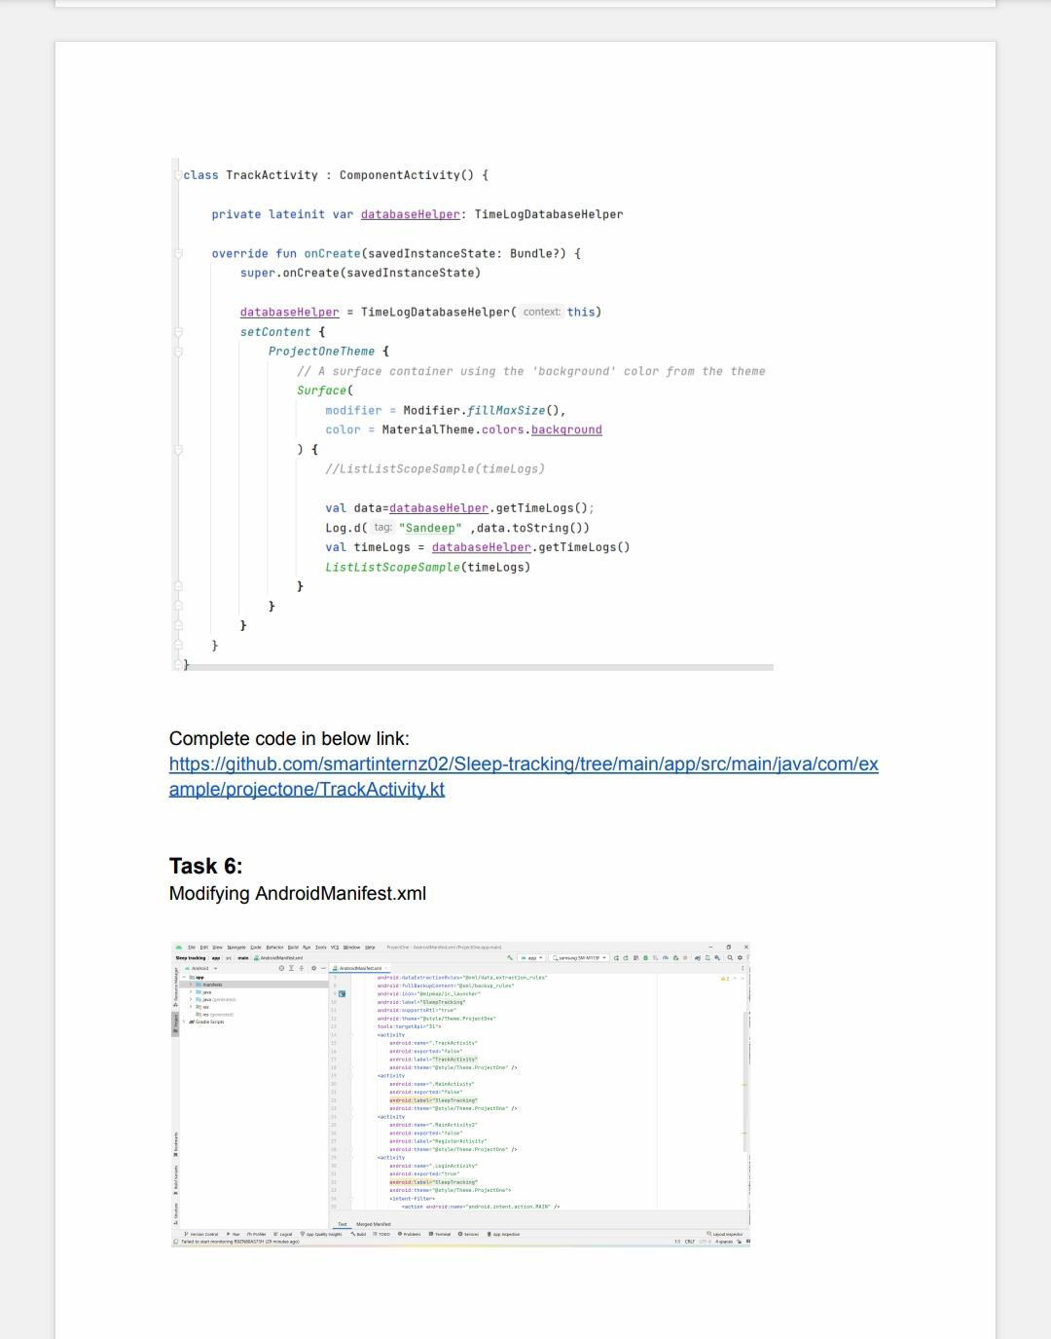

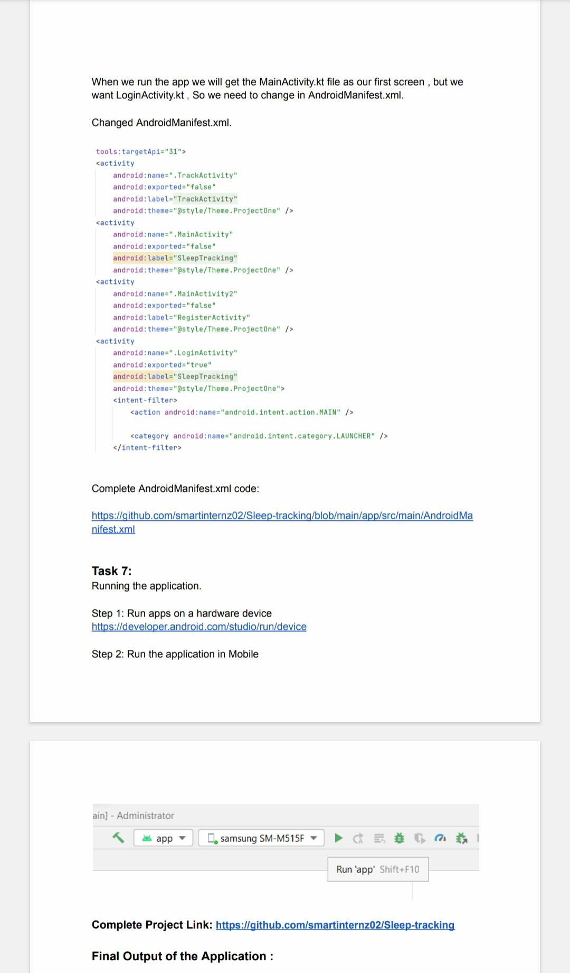

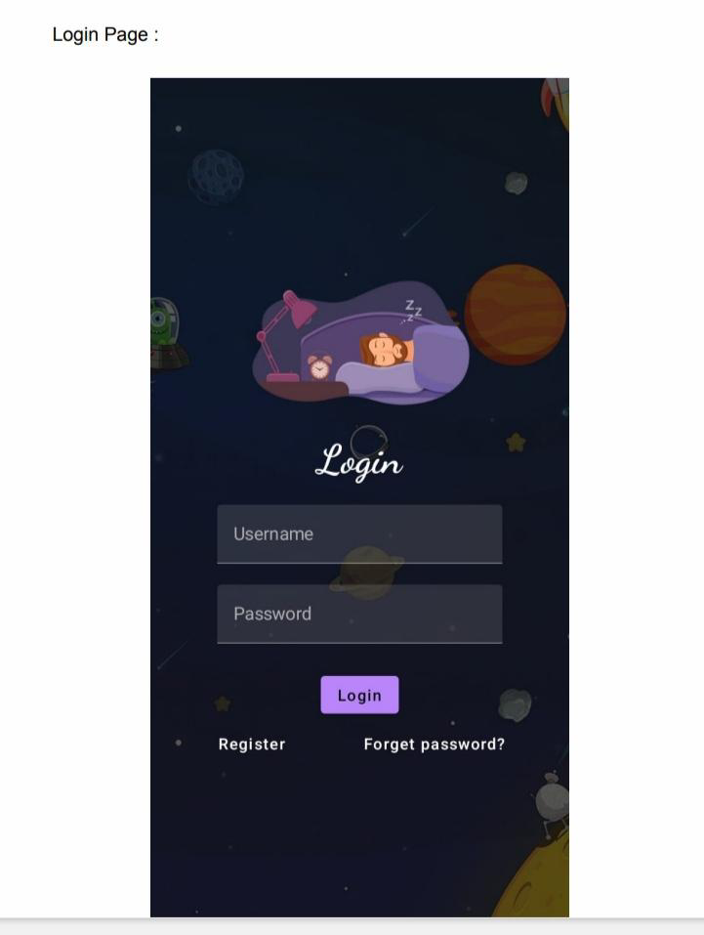

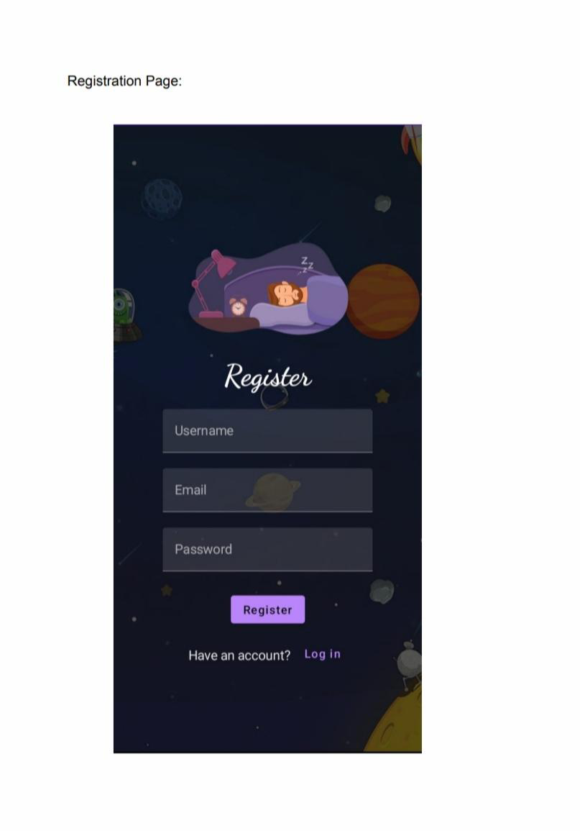

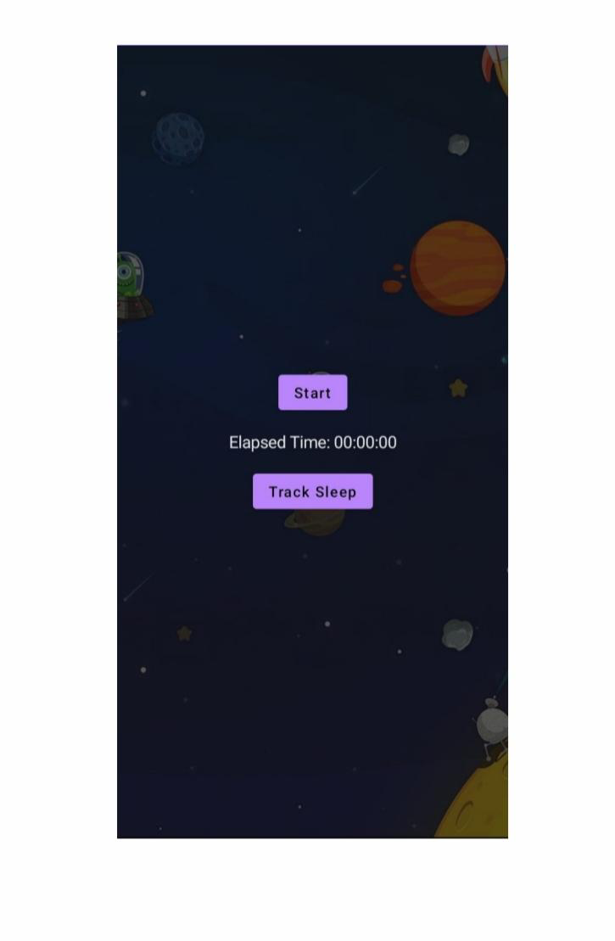

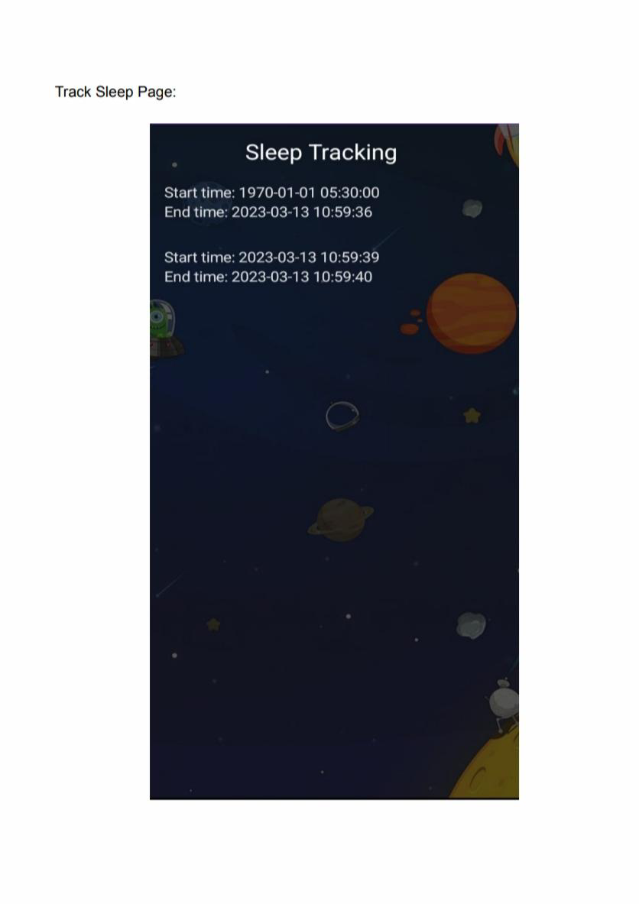

**4. Trailhead Profile Public URL**

Team Lead - https://trailblazer.me/id/rcorel

Team Member 1 -http://trailblarzer.me/id/ritthikkumar

Team Member 2 - https://trailblazer.me/id/r20h3t0

Team Member 3 –https://trailblazer.me/id/rupangnanarajj

**5.ADVANTAGES & DISADVANTAGE**

**Advantage**

* Sleep duration: By tracking the time you’re inactive, the devices can record when you fall asleep at night and when you stir in the morning.
* Sleep quality: Trackers can detect interrupted sleep, letting you know when you’re tossing and turning or waking during the night.
* Sleep phases: Some tracking systems track the phases of your sleep and time your alarm to go off during a period when you’re sleeping less deeply. In theory, that makes it easier for you to rouse.
* Environmental factors: Some devices record environmental factors like the amount of light or temperature in your bedroom.
* Lifestyle factors: Some trackers prompt you to enter information about activities that can affect sleep, such as how much caffeine you’ve had, when you’ve eaten or whether your stress level is high.

**Disadvantage**

* Time Expenditure :Setting up and using sleep trackers can take a lot of time and research, especially if you’re serious about sleep. To actually enjoy the benefits sleep trackers bring, it’s important to review the data collected and reported, and consider and take any suggested action. For some users, this is just too much time and effort to invest.
* Overthinking :The mere act of buying and learning to use a sleep tracker is more than enough to make some users overthink their sleep. This can often get people into their heads and hinders sleep more than helping it.
* Limited Feedback and Reliability :Although sleep trackers track multiple aspects of physiology during sleep, false positives are possible drawbacks. Depending on the device and the type of sleeper, data reliability needs to be considered. For example, many people frequently move during the night, which can trigger your device into thinking you’re no longer asleep. The same goes for sleep talking.
* The temptation to Check During the Night :Knowing that a device monitors your current state increases the temptation to look and check how your sleep is going. This is a bad idea, obviously, since it may trigger anxiety or insomnia due to less-than-optimum results.

**6. APPLICATIONS**

**Learning Outcomes :**

By end of this project:

● You’ll be able to work on Android studio and build an app.

● You’ll be able to integrate the database accordingly.

**Project Workflow**:

Users register into the application.

● After registration , user logins into the application.

● User enters into the main page

● User can track the sleep timing and he record the time

**7.CONCLUSION**

You should also skip sleep trackers if less-than-stellar results tend to upset you. In fact, there’s a term for that: orthosomnia, a preoccupation with perfecting one’s sleep data. Kelly Baron, PhD, a clinical psychologist now at the University of Utah, coined the term when she noticed a spike in patients riddled with anxiety about their supposedly poor sleep duration and quality. If that describes you, you’re probably better off relying more on how you feel throughout the day to figure out how well you slept. But if you enjoy geeking out on exploring your quantified self, come what may, give these apps a go. Many offer free trials, so you have nothing to lose (except sleep).

You can find all kinds of sleep trackers, including standalone devices that sit on your nightstand or under your mattress; wearables, such as masks or rings; and others as features built into fitness trackers and smartwatches. We focused on apps because they’re accessible and relatively inexpensive, which makes them far more appealing to most people.

**8 .FUTURE SCOPE**

The report combines extensive quantitative analysis and exhaustive qualitative analysis, ranges from a macro overview of the total market size, industry chain, and market dynamics to micro details of segment markets by type, application and region, and, as a result, provides a holistic view of, as well as a deep insight into the Sleep Monitoring Apps market covering all its essential aspects.

For the competitive landscape, the report also introduces players in the industry from the perspective of the market share, concentration ratio, etc., and describes the leading companies in detail, with which the readers can get a better idea of their competitors and acquire an in-depth understanding of the competitive situation. Further, mergers and acquisitions, emerging market trends, the impact of COVID-19, and regional conflicts will all be considered.

In a nutshell, this report is a must-read for industry players, investors, researchers, consultants, business strategists, and all those who have any kind of stake or are planning to foray into the market in any manner.